 

A Minor Project-2 Report

On

**IMAGE ENCRYPTION AND DECRYPTION USING CAPSNET ALGORITHM**

Submitted in partial fulfillment of requirements for the reward of the

Degree of

**BACHELOR OF TECHNOLOGY**

In

**ARTIFICIAL INTELLIGENCE AND DATA SCIENCE**

Under the guidance of

**Ms. A. NITHYASRI**

**AP/AI&DS**

**Submitted by**

**LAVANYA DEVI K - 927621BAD026**

**MADHUMITHRA M - 927621BAD029**

**MAHALAKSHMI R - 927621BAD030**

**YUVASHREE S - 927621BAD063**

**DEPARTMENT OF**

**ARTIFICIAL INTELLIGENCE AND DATA SCIENCE**

**M.KUMARASAMY COLLEGE OF ENGINEERING**

(Autonomous)

KARUR – 639113

MAY-2023

**VISION AND MISSION OF THE INSTITUTE:**

**Vision:**

* To emerge as a leader among the top institutions in the field of technical education.

**Mission:**

* Produce smart technocrats with empirical knowledge who can surmount global challenges.
* Create a diverse, fully-engaged, learner-centric campus environment to provide quality education to the students.
* Maintain mutually beneficial partnerships with our alumni, industry, and professional associations.

**VISION AND MISSION OF THE DEPARTMENT:**

**VISION**

* To reach excellent standards of quality education by using the latest tools and to be the Centre of excellence by promoting knowledge-centric education, innovation, and state-of-art research in the field of Artificial Intelligence and Data Science.

**MISSION**

* To impart quality and value-based education and contribute towards the innovation of computing, expert systems, Data Science to raise the satisfaction level of all stakeholders.
* To educate future computing engineers with strong fundamentals by continuously improving the teaching learning methodologies using contemporary aids.
* Enables students to get expertise in critical skills with the Artificial Intelligence domain and facilitate socially responsive research and innovation.
* To encourage professional development of students that will include ethical values and leadership skills while working with the community to address societal issues.

**PROGRAMME OUTCOMES (POs)**

* **Engineering knowledge:** Apply the knowledge of mathematics, science, engineering fundamentals, and an engineering specialization to the solution of complex engineering problems.
* **Problem analysis:** Identify, formulate, review research literature, and analyze complex engineering problems reaching substantiated conclusions using first principles of mathematics, natural sciences, and engineering sciences.
* **Design/development of solutions:** Design solutions for complex engineering problems and design system components or processes that meet the specified needs with appropriate consideration for the public health and safety, and the cultural, societal, and environmental considerations.
* **Conduct investigations of complex problems:** Use research-based knowledge and research methods including design of experiments, analysis and interpretation of data, and synthesis of the information to provide valid conclusions.
* **Modern tool usage:** Create, select, and apply appropriate techniques, resources, and modern engineering and IT tools including prediction and modeling to complex engineering activities with an understanding of the limitations.
* **The engineer and society:** Apply reasoning informed by the contextual knowledge to assess societal, health, safety, legal and cultural issues and the consequent responsibilities relevant to the professional engineering practice.
* **Environment and sustainability:** Understand the impact of the professional engineering solutions in societal and environmental contexts, and demonstrate the knowledge of, and need for sustainable development.
* **Ethics:** Apply ethical principles and commit to professional ethics and responsibilities and norms of the engineering practice.
* **Individual and teamwork:** Function effectively as an individual, and as a member or leader in diverse teams, and in multidisciplinary settings.
* **Communication:** Communicate effectively on complex engineering activities with the engineering community and with society at large, such as being able to comprehend and write effective reports and design documentation, make effective presentations, and give and receive clear instructions.
* **Project management and finance:** Demonstrate knowledge and understanding of the engineering and management principles and apply these to one’s own work, as a member and leader in a team, to manage projects and in multidisciplinary environments.
* **Life-long learning:** Recognize the need for, and have the preparation and ability to engage in independent and life-long learning in the broadest context of technological change.

**PROGRAM SPECIFIC OUTCOMES (PSOs)**

* + **Professional Skills:** Ability to apply the knowledge of computing techniques to design and develop computerized solutions for the problems.
  + **Successful career:** Ability to utilize the computing skills and ethical values in creating a successful career.
  + Engineering knowledge
  + Problem analysis
  + Design/development of solutions
  + Modern tool usage
  + Environment and sustainability
  + Individual and teamwork
  + Life-long learning
  + **PSO’S:** Professional Skills

**MAPPING OF PROJECT WITH PO’S AND PSOs:**

* + Engineering knowledge
  + Problem analysis
  + Design/development of solutions
  + Modern tool usage
  + Environment and sustainability
  + Individual and teamwork
  + Life-long learning
  + **PSO’S:** Professional Skills

# M.KUMARASAMY COLLEGE OF ENGINEERING

**(Autonomous Institution affiliated to Anna University, Chennai)**

## BONAFIDE CERTIFICATE

Certified that this project report **“IMAGE ENCRYPTION AND DECRYPTION USING CAPSET ALGORITHM”** is the Bonafide work of **“LAVANYA DEVI K (927621BAD026), MADHUMITHRA M (927621BAD029), MAHALAKSHMI R (927621BAD030) and YUVA SHREE S (927621BAD063)”** who carried out the minor project work during the academic year 2022-2023 under our supervision. Certified further, that to the best of our knowledge the work reported herein does not form part of any other minor project report or dissertation on the basis of which a degree or award was conferred on an earlier occasion on this or any other candidate.

**Signature**

MS. A. NITHYASRI

Assistant Professor,

Department of Artificial Intelligence and Data science,

M.Kumarasamy College of Engineering,

Thalavapalayam,

Karur-639113.

**Signature**

Dr.N.M. SARAVANA KUMAR

Head of the Department

Department of Artificial Intelligence and Data science,

M.Kumarasamy College of Engineering,

Thalavapalayam,

Karur-639113.

**TABLE OF CONTENTS**

|  |  |  |
| --- | --- | --- |
| **CHAPTER NO** | **TITLE** | **PAGE NO** |
|  | **ABSTRACT** | **6** |
|  | **LIST OF FIGURES** | **7** |
|  | **LIST OF TABLES** | **8** |
|  | **ACRONYMS/LIST OF ABBREVIATIONS** | **8** |
| **1** | **CHAPTER I-INTRODUCTION**  1.1 Introduction  1.2 Objectives  1.3 Problem Statement | **9**  **10**  **11**  **11** |
| **2** | **CHAPTER II**  2.1 Literature survey | **12**  **13** |
| **3** | **CHAPTER III**  Feasibility Study | **15**  **16** |
| **4** | **CHAPTER-IV**  4.1 Methodology  4.2 Features | **18**  **19**  **19** |
| **5** | **CHAPTER-V**  5.1 Block Diagram  5.2 Important Packages Used | **22**  **23**  **23** |
| **6** | **CHAPTER-VI**  Result | **25**  **26** |
| **7** | **CHAPTER-VII**  Conclusion | **28**  **29** |
| **8** | **CHAPTER-VIII**  References | **30**  **31** |

**ABSTRACT**

Capsule Networks (CapsNets) are a type of neural network that have shown promising results in image processing tasks, including image classification and object recognition. In recent years, there has been growing interest in using CapsNets for image encryption.

Image encryption is the process of transforming an image into a form that is unreadable to anyone except the intended recipient, who possesses the key to decrypt the image. Abstract image encryption refers to the process of encrypting images that have no discernible visual content or structure, such as noise or random patterns.

Using CapsNets for abstract image encryption involves training the network to encode the abstract image into a set of capsules, which represent different parts or features of the image. The capsules are then scrambled and encrypted using a key, making the original image unreadable to anyone who doesn't have the key.

To decrypt the encrypted image, the recipient uses the same key to unscramble the capsules and reconstruct the original image. CapsNets have shown promise in this task because they are able to learn the underlying structure of the image, even if it is abstract or unstructured.

However, there are still challenges to overcome in using CapsNets for image encryption, such as ensuring the security of the key and preventing the network from overfitting to the training data. Nonetheless, the potential of CapsNets in abstract image encryption suggests that they may be a valuable tool for secure communication and image protection.

### **LIST OF FIGURES**

|  |  |  |
| --- | --- | --- |
| **Figure No** | **Figure Name** | **Page No** |
| 1 | Block Diagram | 23 |
| 2 | Home Page | 26 |
| 3 | Converting Image Into Array | 26 |
| 4 | Framing The Encryption Key | 26 |
| 5 | Encrypted Image | 27 |

**LIST OF TABLES:**

|  |  |  |
| --- | --- | --- |
| **Table No** | **Table Name** | **Page No** |
| 1 | Literature review | 14 |
|  |  |  |
|  |  |  |
|  |  |  |

**ACRONYMS/LIST OF ABBREVIATIONS:**

|  |  |
| --- | --- |
| **Acronym** | **Abbreviations** |
| API | Application Programming Interface |

### 

### CHAPTER-1

**INTRODUCTION**

# 

# INTRODUCTION

### The increasing importance of data security has led to the widespread use of encryption techniques to secure data. Images, in particular, contain sensitive and confidential information, and it is essential to protect them from unauthorized access. Capsule networks (CapsNets) have shown promising results in image recognition and segmentation tasks. In this project, we explore the feasibility of using CapsNets for image encryption.

### **OBJECTIVES**

Develop a more secure encryption algorithm that is resistant to hide the images from unauthorized access.By using Capsnet neural network in order to secure the image from an illegal remote.

**PROBLEM STATEMENT**

The advanced computer processors have made it easy to illegally access the transmitted data on the Internet. So, the challenge of secure image encryption and decryption is daunting, as a single flaw in the process can leave the data unsafe.

### CHAPTER-2

**LITERATURE REVIEW**

**LITERATURE SURVEY**

|  |  |  |
| --- | --- | --- |
| Author | Year | Descriptions |
| H. Zhou, L. Xu, and J. Qin | 2021 | Proposed CapsNet architecture to extract features from the input image and then apply a permutation operation to the feature vectors. |
| S.Li,Y.Li and H.Li | 2021 | Proposed an image encryption scheme based on CapsNets and chaotic systems. They use the CapsNet to extract features from the input image and then apply a chaotic map to the feature vectors. |
| X. Wang, C. Zhang, and Y. Guo | 2020 | Presents a novel image encryption algorithm based on CapsNets. The authors use the CapsNet architecture to extract features from the input image and then perform a series of encryption operations, including permutation, substitution, and diffusion. Experimental results show that their method is efficient and secure.. |
| S. Han, S. Kim, and S. Lee | 2020 | Proposed an image encryption scheme based on CapsNets and chaotic maps. They use the CapsNet to extract features from the input image and then apply a series of encryption operations, including permutation, substitution, and diffusion. Experimental results show that their method is effective and robust against attacks. |
| Y. Li, Q. Lu, and H. Li | 2019 | Proposed an image encryption scheme based on CapsNets and compressed sensing. The authors use the CapsNet to extract features from the input image and then apply a compressed sensing algorithm to compress the feature vectors. Experimental results show that their method achieves high security and efficiency. |

### CHAPTER-3

**FEASIBILITY STUDY**

**FEASIBILITY STUDY**

The Feasibility study can help you determine whether or not you should proceed with your project. It is essential to evaluate the cost and benefit. It is essential to evaluate the cost and benefit of the proposed system. Five types of feasibility study are taken into consideration.

1. **Technical feasibility:**

It involves encoding the features of an image using capsules and then encrypting the capsule outputs. For an image encryption, must have an availability of data to convey their image. Besides, the system needs an internet connection. While using image encryption, make sure you have a steady internet connection. It is also not an issue in this era where almost every home or office has Wi-Fi.

1. **Operational feasibility:**

It is the ease and simplicity of operation of the proposed system. System does not require any special skill set for users to operate it. In fact, it is designed to be used by almost everyone. CapsNet-based image encryption can provide users with a secure and reliable method of encrypting their sensitive image data.

1. **Economic feasibility:**

Here, we find the total cost and benefit of the proposed system over the current system. For this project, the main cost is documentation cost. The cost of hardware and software resources, as well as training and support, can be managed effectively to ensure that the system is affordable for users. The cost of integration, maintenance, and upgrades can be minimized through careful planning and implementation.

**4. Organizational feasibility:**

This shows the management and organizational structure of the project. This project is built by a team. The management tasks are all to be carried out by a team. That won’t create any management issues and will increase the feasibility of the project.

**5. Cultural feasibility:**

It deals with compatibility of the project with the cultural environment. Image encryption is built in accordance with the general culture. This project is technically feasible with security and privacy to the users. Also, it is simple in operation and does not cost training or repairs. Overall feasibility study of the project reveals that the goals of the proposed system are achievable. Decision is taken to proceed with the project.

### CHAPTER-4

**PROJECT METHODOLOGY**

**PROJECT METHODOLOGY**

**Methodology**

The first step is to preprocess the input image. The image is resized and normalized to prepare it for the CapsNet model.The next step is to apply the CapsNet model to the preprocessed image.Capsule routing is an important concept in CapsNets and by using the process of routing the capsules are brought from the lower layer to the higher layer.Then mask the input image using a random binary mask. This mask contains ones and zeros, and it is multiplied element-wise with the input image.The masked image is then fed into the CapsNet model. The encoder processes the masked image and produces a set of capsules that represent the masked object's pose and presence.The binary mask used for masking the input image is used as the encryption key. This key is then shared with the receiver to decrypt the encrypted image.To decrypt the encrypted image, the receiver first masks the encrypted image using the same binary mask used for encryption.The model processes the masked image and produces a set of capsules that represent the masked object's pose and presence. The capsules are then routed to the decoder to reconstruct the original image.

**Features**

* Data Preprocessing
* CapsNet Model
* Capsule Routing
* Masking
* Capsule Prediction
* Encryption Key
* Decryption

**Data Preprocessing**

The first step is to preprocess the input image. The image is resized and normalized to prepare it for the CapsNet model.

**CapsNet Model**

The next step is to apply the CapsNet model to the preprocessed image. The CapsNet model has two main components: the encoder and the decoder. The encoder processes the image and produces a set of capsules that represent the object's pose and presence. The decoder then reconstructs the image from the capsules.

**Capsule Routing**

Capsule routing is an important concept in CapsNets. It is the process of routing the capsules from the lower layer to the higher layer. Capsules in the lower layer send their outputs to the higher layer capsules based on their agreement. Capsules that agree on the pose of the object send their outputs to the same higher layer capsule. This helps in improving the robustness of the model.

**Masking**

Once the CapsNet model is trained, we can use it for image encryption. For this, we first mask the input image using a random binary mask. This mask contains ones and zeros, and it is multiplied element-wise with the input image.

**Capsule Prediction**

           The masked image is then fed into the CapsNet model. The encoder processes the masked image and produces a set of capsules that represent the masked object's pose and presence. These capsules are then routed to the decoder to reconstruct the masked image.

**Encryption Key**

The binary mask used for masking the input image is used as the encryption key. This key is then shared with the receiver to decrypt the encrypted image. The project can include features to ensure secure and efficient management of encryption keys.

**Decryption**

To decrypt the encrypted image, the receiver first masks the encrypted image using the same binary mask used for encryption. The masked image is then fed into the CapsNet model. The model processes the masked image and produces a set of capsules that represent the masked object's pose and presence. The capsules are then routed to the decoder to reconstruct the original image.

## Result

The project developed using image encryption using CapsNets can offer several features that make it a powerful and user-friendly tool for securing digital images. These include security, a user-friendly interface, robustness, speed, encryption key management, compatibility, and documentation and support.

CHAPTER-5

**IMPLEMENTATION**

**IMPLEMENTATION**

**5.1 BLOCK DIAGRAM**

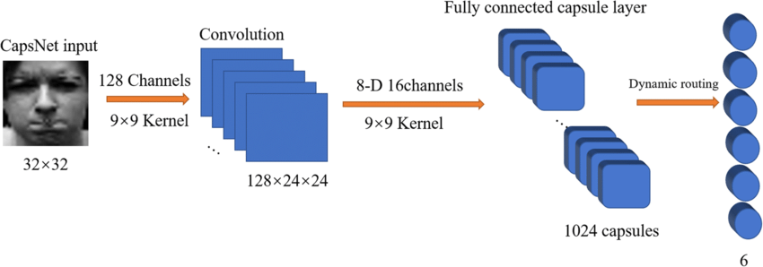

**5.2 IMPORTANT PACKAGES USED**

* Keras
* TensorFlow
* OpenCv
* Numpy

**KERAS**

Keras is an open-source neural network library written in Python that supports CapsNet architecture. Keras has a user-friendly API and can be used for building complex neural networks, including CapsNet-based models.

**TENSORFLOW**

TensorFlow is a popular open-source machine learning framework developed by Google. It supports the implementation of CapsNet models and provides a wide range of tools and libraries for image processing.

**OPENCV**

OpenCV (Open Source Computer Vision Library) is a popular computer vision library that can be used for image processing tasks. It provides a range of tools and algorithms for image encryption and decryption, and it can be used in conjunction with CapsNet-based models.

**NUMPY**

NumPy can be used to read image files, convert them to arrays, and perform various image processing tasks such as cropping, resizing, and filtering. These processed images can then be fed into CapsNet models for encryption and decryption.

CHAPTER-6

**RESULT**

**RESULT**

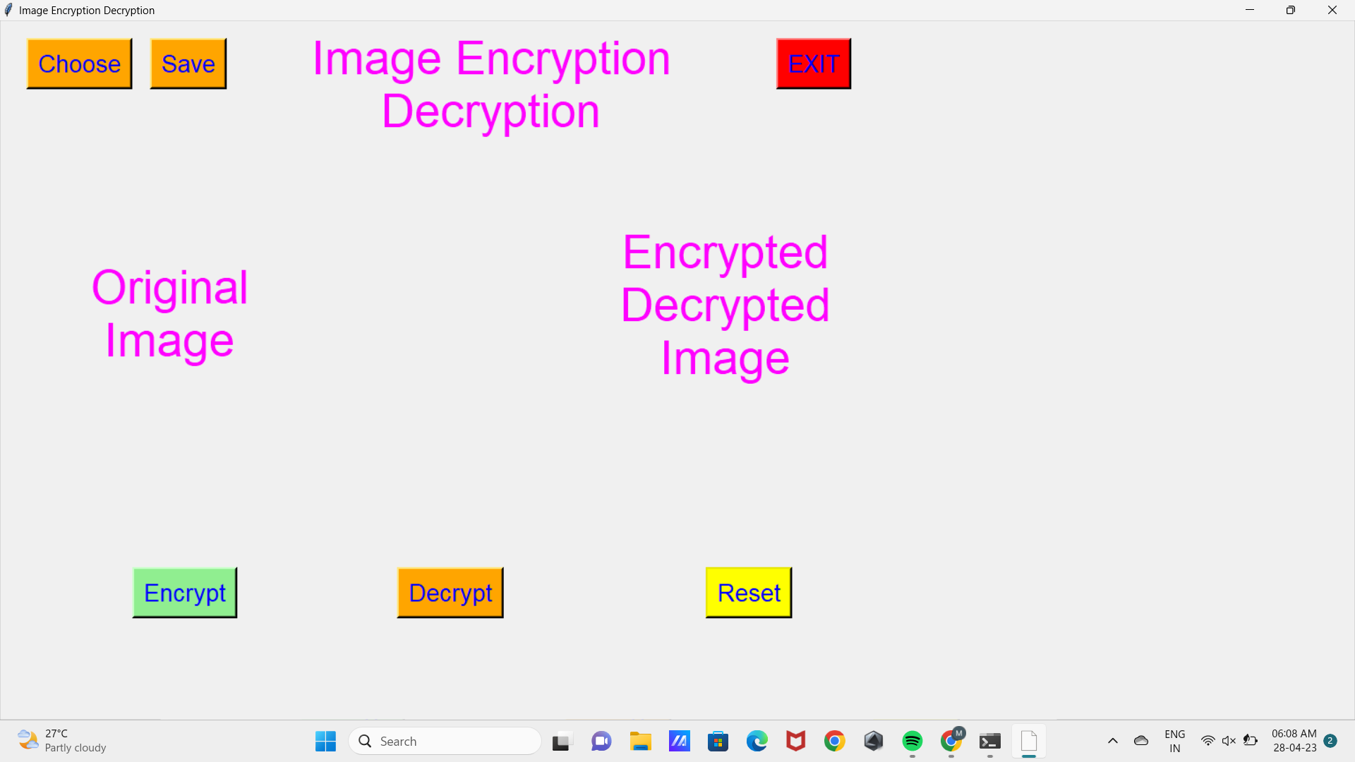

**HOME PAGE**

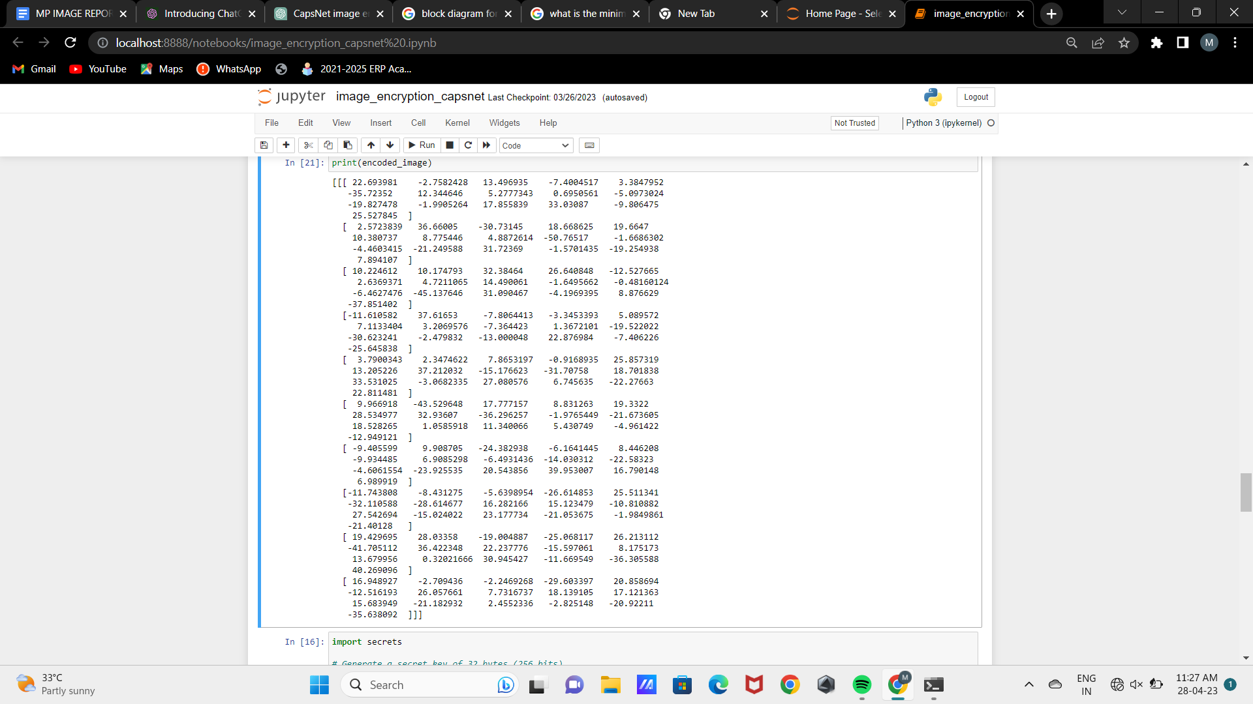

**CONVERTING IMAGE INTO ARRAY**

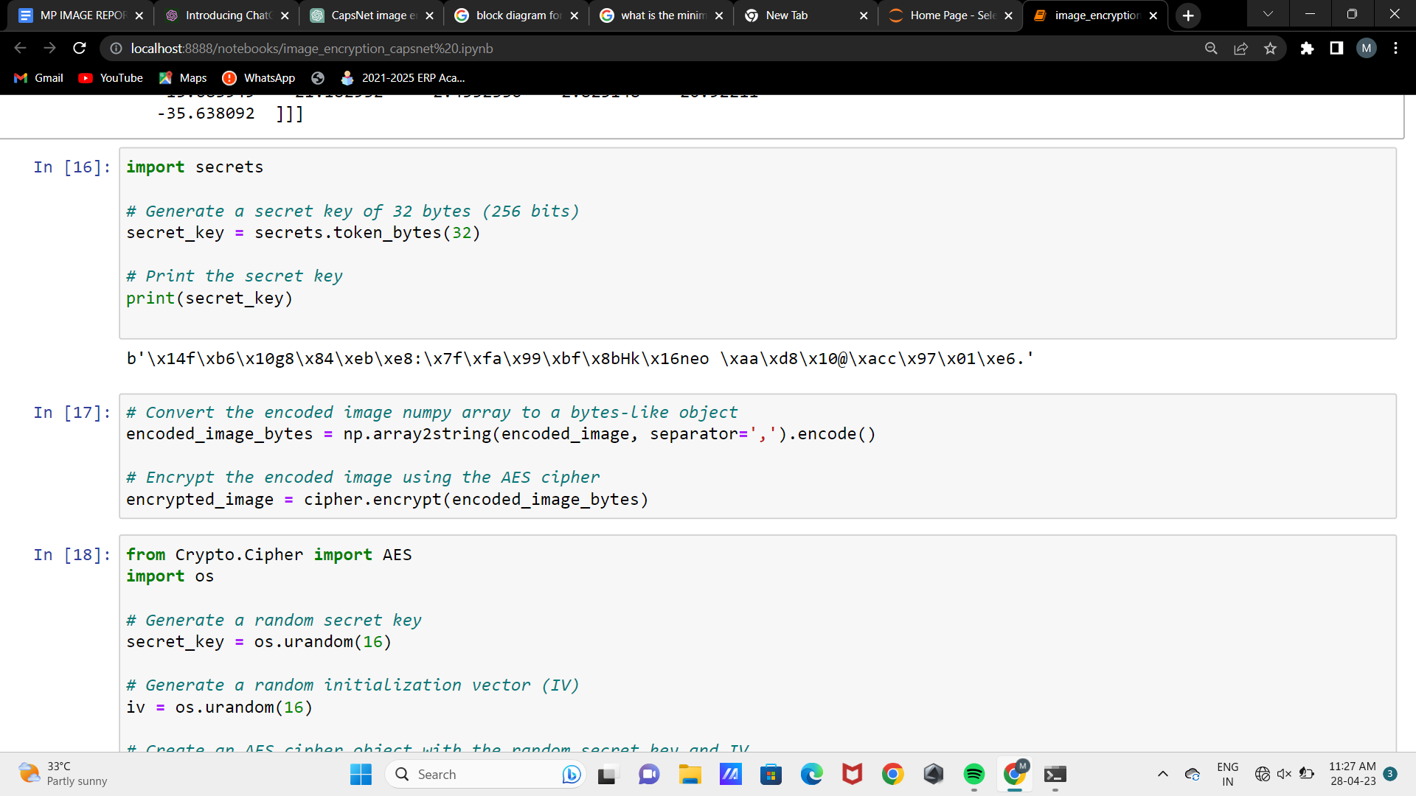

**FRAMING THE ENCRYPTION KEY**

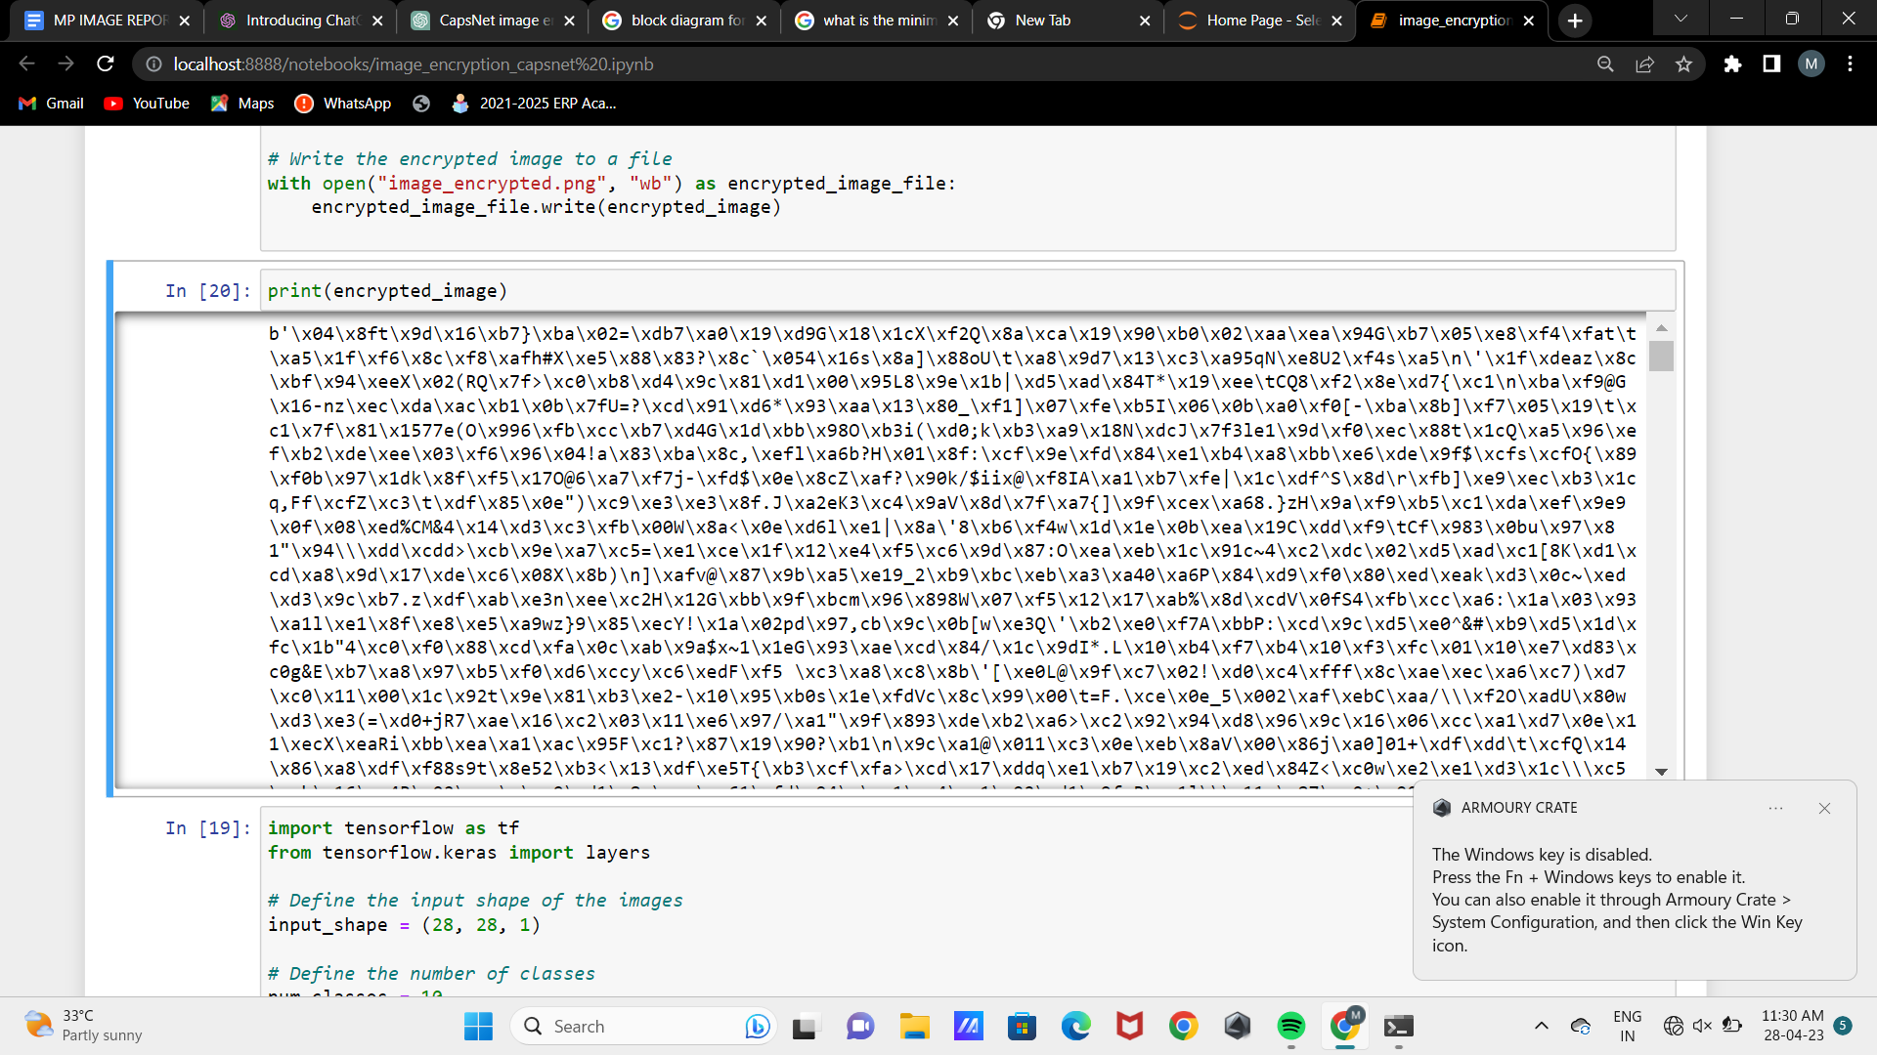

**ENCRYPTED IMAGE**

CHAPTER-7

**CONCLUSION**

**CONCLUSION**

We created a web application to help the parents communicate with the website in an easy and comfortable native language to get the details of the student. To improve the study and career of the students, it also helps to notify parents if any events and functions are done in the organization.

And the data are the students are being displayed as pdf file format using voice commands and the replica can replay back to the parents as their native language and the teacher’s login page is created to upload the pdf files to the corresponding student’s profile for easy accessing database.

CHAPTER-8

**REFERENCES**

**REFERENCE**

1.Wang, H., Li, Y., Li, C., Li, H., & Liu, Y. (2020). An image encryption scheme using capsule network and DNA sequence operations. Signal Processing: Image Communication, 84, 115799. https://doi.org/10.1016/j.image.2020.115799

2.Yang, S., Guo, Y., & Sun, J. (2021). Image encryption based on capsule network and fractional Fourier transform. Multimedia Tools and Applications, 80(11), 16525-16542. https://doi.org/10.1007/s11042-021-10923-6

3."Capsule Networks: A Survey" by Xiao Sun et al. (2019). This survey paper provides an overview of CapsNet research, including architecture, applications, and challenges.

4. "Capsule Network Performance on Complex Data" by Abhinav Gupta et al. (2022). This paper evaluates the performance of CapsNets on complex data

5. "Capsule Networks for Object Recognition: A Survey" by Seyed Mehran Kazemi and Ali Jalalifar (2021)

**THANK YOU**